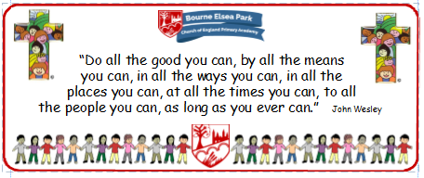

Bourne Elsea Park C of E Primary Academy
Collective Worship Council Minutes
CV: Respect & Reverence
Date: Thursday 3rd October 12.30pm

PRESENT: Mrs Simpson (AS), Euan, Samyu, Sophia, Nathan, Luke, Olivia, Harley, Aubree

APOLOGIES AND WELCOME:
No apologies
AS welcomed the councillors

MEETING:
There was a discussion about what exactly they thought the role of a CWC was and the expectations from AS.
Role of a CWC:
- To be an active part of the EP family that helps pupils to learn more about Christianity
- To work alongside AS to plan, take and evaluate their own CW within school
- To welcome Jesus into each CW by lighting the candle and leading our special words
- To be the voice of each class
- To welcome the children into the hall as they enter CW
- To take care of the classroom Reflection Area
- To encourage peers to use the Reflection Areas
- To model using extempore prayers in CW
- To model good choices in and out of CW

AS explained the activity in the main Reflection Area and asked the CWC to encourage their peers to investigate and use it.
AS asked the councillors to look at their classroom reflection areas and make a list of what is in there, what they think it needs and how much and why it is being used.
AS asked the councillors to write a prayer linked with the CV of Respect to be included in the CW newsletter to parents.
Our British Values
We value democracy and make sure everybody has a say.

DATE FOR THE NEXT MEETING: Thursday 17th October 12.30pm

ACTION LOG:
- CWC to spend time in their classroom Reflection Areas looking at the contents
- CWC to talk to class about the Reflection Area
- CWC to write a prayer / part of a prayer

