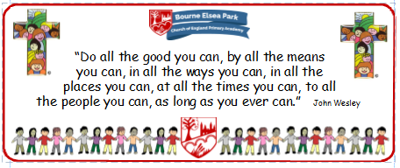

Bourne Elsea Park C of E Primary Academy
Collective Worship Council Minutes
CV: Compassion
Date: Wednesday 5th March 2020 12.30pm

PRESENT: Mrs Simpson (AS), Euan, Samyu, Sophia, Nathan, Luke, Olivia,

APOLOGIES AND WELCOME:
No apologies.
AS welcomed the councillors to the meeting.

MEETING:
AS told the councillors that they needed to add some bits and pieces to the new website.
- Meet the CWC video
- Reflection Areas video with school singing My Lighthouse backing track
- What is the role of a CWC video

The Meet the CWC video was taken in front of the main Reflection Area.

AS told the CWC that she was speaking to the Governors later in the day about CW and the CWC. The councillors chose the evaluation form they wanted the Governors to have and she showed them the page from this term’s Padlet that they were going to have too.
AS explained that she was going to ask one of the Governors to attend one of their meetings and said it would probably be Mr Nick Page.

DATE FOR THE NEXT MEETING: TBC after the Governors meeting
Our British Values
We value democracy and make sure everybody has a say.

ACTION LOG:
- AS to attend the Governors meeting
- CWC to continue to think about their forthcoming CW focus.

