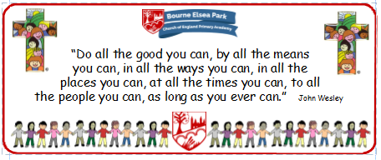

Bourne Elsea Park C of E Primary Academy
Collective Worship Council Minutes
CV: Peace
Date: Thursday 5th December 12.30pm

PRESENT: Mrs Simpson (AS), Euan, Samyu, Sophia, Nathan, Luke, Olivia, Harley, Aubree

APOLOGIES AND WELCOME:
No apologies
AS welcomed the councillors to the meeting.

MEETING:
AS asked the councillors how they thought the advent CW went. Samyu said she was surprised that so many children remembered the facts about Advent especially Alfred (Y4).
AS handed out the words for the second advent CW.

DATE FOR THE NEXT MEETING: Thursday 12th December 12.30pm
Our British Values
We value democracy and make sure everybody has a say.

ACTION LOG:
- CWC to practice their words for the Advent CW

