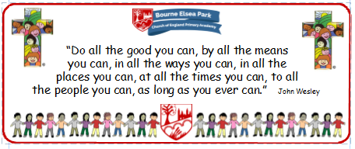

Bourne Elsea Park C of E Primary Academy
Collective Worship Council Minutes
CV: Courage
Date: Thursday 6th February 2020 12.30pm

PRESENT: Mrs Simpson (AS), Euan, Samyu, Sophia, Nathan, Luke, Olivia,

APOLOGIES AND WELCOME:
No apologies.
AS welcomed the councillors to the meeting.

MEETING:
There was a discussion about the Candlemass CW on Tuesday. The councillors said they thought it went very well. Their peers said they heard every word and they all enjoyed the video clip found by Luke.
AS asked if they felt:
- they had put enough information on – yes.
- the pictures were appropriate - yes
- the school had learnt something – yes
- they needed to change anything – yes, brighter and more interesting slides for the children to llok at while the CWC are speaking

AS talked about a Bible Journaling Bible that BAPA had introduced. She had borrowed the one from BAPA and explained how it worked. The councillors loved the idea and agreed this would be something they would love to do.

DATE FOR THE NEXT MEETING: Wednesday 5th March 12.30pm
Our British Values
We value democracy and make sure everybody has a say.

ACTION LOG:
- AS to order the Bible for Bible Journaling

