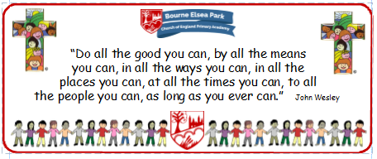

Bourne Elsea Park C of E Primary Academy
Collective Worship Council Minutes
CV: Courage
Date: Thursday 9th January 2020 12.30pm

PRESENT: Mrs Simpson (AS), Euan, Samyu, Sophia, Nathan, Luke, Olivia, Harley, Aubree

APOLOGIES AND WELCOME:
No apologies
AS welcomed the councillors to the meeting and apologised for the councillors not being able to lead the third and fourth advent CWs as she was absent from school in the final week of term.

MEETING:
AS told the councillors about their next CW. She asked them to research Candlemass or the Presentation of Christ which falls on 2nd February. AS reminded the children that she had mentioned Candlemass in her CW the week before when she was talking about Epiphany. As said they had 2 weeks to research this and to bring their notes to the next meeting.

AS asked the councillors ‘What is the difference between CW and Assembly?’
Euan said Assembly is when you don’t do things like light the candle and say a prayer. Samyu said everything in CW is Christian. Luke said assembly is when you have things like visitors in who don’t talk about the Bible. AS told them they were quite right and that it was important for them to know the difference.

Olivia asked if she would be able to light the CW candle and AS said at the moment it was going to be the job for Yr 5 and 6.

AS shared the news that the staff had chosen Nathan’s design for the evaluation sheet but asked if the pictures from Sophia’s and Olivia’s could be added. AS said that the councillors would be starting to use these soon.

DATE FOR THE NEXT MEETING: Thursday 23rd January 12.30pm
Our British Values
We value democracy and make sure everybody has a say.

ACTION LOG:
- CWC to research Candlemass and bring notes to the next meeting.

