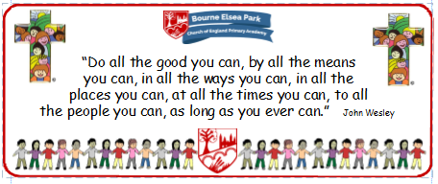

Bourne Elsea Park C of E Primary Academy
Collective Worship Council Minutes
CV: Peace
Date: Thursday 12th December 12.30pm

PRESENT: Mrs Simpson (AS), Euan, Samyu, Sophia, Nathan, Luke, Olivia, Harley, Aubree

APOLOGIES AND WELCOME:
No apologies
AS welcomed the councillors to the meeting.

MEETING:
AS asked the councillors how they thought the advent CW went. They said they thought it went very well. As said that some children said they couldn’t hear some of the words so they practised using their CW voices!
AS handed out the words for the third advent CW – Tuesday 17th December.

DATE FOR THE NEXT MEETING: Tuesday 17th December 12.30pm to give out final words for 4th Advent CW.
Our British Values
We value democracy and make sure everybody has a say.

ACTION LOG:
- CWC to practice their words for the Advent CW

