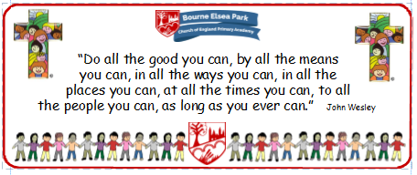

Bourne Elsea Park C of E Primary Academy
Collective Worship Council Minutes
CV: Respect & Reverence
Date: Thursday 17th October 12.30pm

PRESENT: Mrs Simpson (AS), Euan, Samyu, Sophia, Nathan, Luke, Olivia, Harley, Aubree

APOLOGIES AND WELCOME:
No apologies
AS welcomed the councillors to the meeting.

MEETING:
AS asked the councillors to report back about their Reflection Areas (RA)
- Year 6: Euan and Samyu said no-one appeared to use the RA and it needed a Bible and a candle.
- Year 5: Sophia said a few children had been seen using the RA and it had everything on it but she would like another Bible.
- Nathan and Luke said the RA in 4D was good but they hadn’t seen anyone use it.
- Olivia said her RA was fab and she explained about the reflection book Miss Orriss had set up in there.
- Harley said some people used his RA because they knew what to do from Year 1.
- Aubree told the team AS had explained what their RA was for and how to use it.
AS said she was a bit disappointed to hear that pupils were not using the RA as the CWC last year had worked so hard to make the RAs useful and necessary. AS suggested that the CWC went back to their classes and asked their teachers if they could spend some time talking to the class about the RAs.

AS collected the prayer ideas from the CWC and they put the ideas together to make one prayer for the newsletter.

AS said that in the next meeting they were going to talk about evaluating CW. The CWC were very excited!

DATE FOR THE NEXT MEETING: Thursday 7th November 12.30pm
Our British Values
We value democracy and make sure everybody has a say.

ACTION LOG:
- CWC to talk to the class about the RA. AS to speak to staff.

