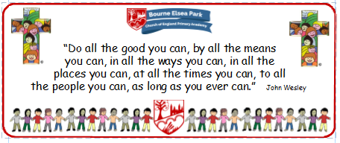

Bourne Elsea Park C of E Primary Academy
Collective Worship Council Minutes
CV: Courage
Date: Thursday 23rd January 2020 12.30pm

PRESENT: Mrs Simpson (AS), Euan, Samyu, Sophia, Nathan, Luke, Olivia,

APOLOGIES AND WELCOME:
No apologies.
AS welcomed the councillors to the meeting.

MEETING:
The councillors showed AS what they had found out about Candlemass. Each councillor in turn read out the information they had and shared nay pictures. Luke said his Grandad had helped him find a short video clip that could be used in the CW. Together the councillors decided which pieces of information were the most important.
The councillors decided they would like to meet again the following week to put together a Powerpoint and decide who was going to say what.

AS asked the councillors for the following for the next CW newsletter:
- An extempore prayer
- What has been their favourite CW?
- What is their favourite CW song?
- What do they enjoy about being a CWC?
AS said she would collate the information and let them see the newsletter before it went out so they could check it and add / take out anything they didn’t like.

DATE FOR THE NEXT MEETING: Thursday 30th January 12.30pm
Our British Values
We value democracy and make sure everybody has a say.

ACTION LOG:
- CWC to bring their Candlemass info to the next meeting.

