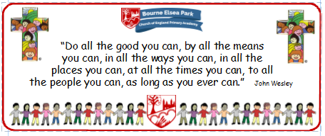

Bourne Elsea Park C of E Primary Academy
Collective Worship Council Minutes
CV: Peace
Date: Thursday 28th November 12.30pm

PRESENT: Mrs Simpson (AS), Euan, Samyu, Sophia, Nathan, Luke, Olivia, Harley, Aubree

APOLOGIES AND WELCOME:
No apologies
AS welcomed the councillors to the meeting.

MEETING:
AS asked the councillors for their evaluation designs and thanked them for taking the time to do them. AS surprised them by saying that the staff were going to choose the ‘winning’ design.

AS talked about the Advent CWs that the councillors were going to lead. She handed out the scripts and words were allocated with Aubree being the only one who didn’t want to speak.
All of the KS2 councillors said they remembered the Advent CW from last year and Samyu asked if there was going to be a wreath again and AS said yes. AS asked the councillors to practice their words but they didn’t have to learn them.
The first Advent CW was to be on Tuesday 3rd December, the second on Tuesday 10th December and the final 2 needed to be confirmed.

DATE FOR THE NEXT MEETING: Thursday 5th December 12.30pm
Our British Values
We value democracy and make sure everybody has a say.

ACTION LOG:
- CWC to practice their words for the Advent CW

