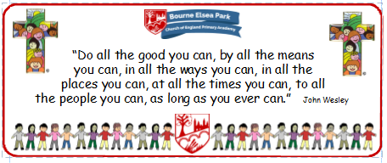

Bourne Elsea Park C of E Primary Academy
Collective Worship Council Minutes
CV: Courage
Date: Thursday 30th January 2020 12.30pm

PRESENT: Mrs Simpson (AS), Euan, Samyu, Sophia, Nathan, Luke, Olivia,

APOLOGIES AND WELCOME:
No apologies.
AS welcomed the councillors to the meeting.

MEETING:
At the meeting today the CWC made their Candlemass powerpoint and allocated parts. The KS2 councillors created the powerpoint. They chose the background colours, the pictures for the screens and wrote their script with a little help from AS. As they were working AS spoke about the next CW that needed to be planned and that is Holy Week and Easter. She said she wanted the councillors to decide for themselves what they wanted the focus and outcome to be.
Once the powerpoint was finished AS printed a copy off for each councillor.

DATE FOR THE NEXT MEETING: Thursday 6th February 12.30pm to discuss how the CW went.
Our British Values
We value democracy and make sure everybody has a say.

ACTION LOG:
- CWC to practise their parts for the CW on Tuesday.
- CWC to start thinking about the next CW in terms of focus and outcome.

