
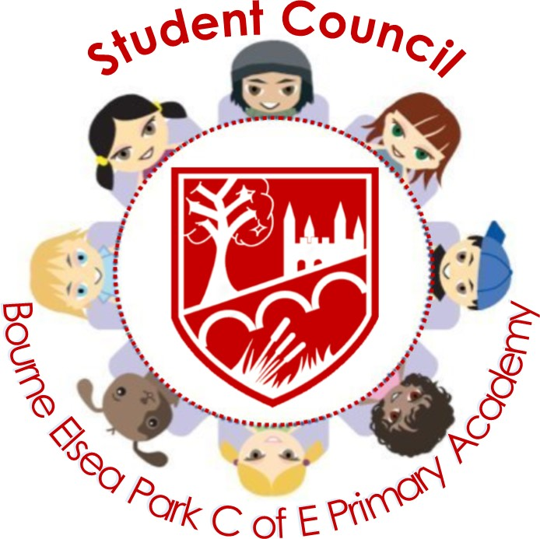

Bourne Elsea Park C of E Primary Academy Student Council (SC)
Minutes of Meetings held on 16.01.25

Distribution.
Y1, Y2, Y3, Y4, Y5, Y6, Miss Davey, Mrs Moore (SLT), Mrs Jordan (SLT) Class Teachers, Mrs Jones, Mrs Bates, Mrs Anderson, Mrs Croxall (Student Council leaders, BAPA, CWS) Mrs Shears, Mr Farnaby (Link Governor)
Present.
Miss Davey, Y1-Y6 Councillors,

1. Welcome, register and apologies
Miss Davey took register and all councillors were present therefore no apologies were given.

2. Playtime/Lunchtime Charters
Miss Davey shared the new Playtime and Lunchtime Charters with Student Council, checking if they were happy with the new wording and the Articles. They agreed with the Articles and liked the ‘We will’ wording as it showed an agreement between pupils and duty bearers. Miss Davey said that they would be re-launched in Collective Worship during the following week. Student Council would then put them up around the school and out on the playground.

3. New bench
Miss Davey discussed the state of some of the benches on the playground and let the councillors know that PTFA would be able to fund a new table/bench. The councillors agreed that another recycled rainbow table/bench would be good. Miss Davey said she would feed this back to the PTFA.

4. Letter to local Secondary Schools
Miss Davey reminded the councillors that during the UNICEF Gold reaccreditation, it had been discussed that the children felt sad that neither Bourne Grammar or Bourne Academy were UNICEF Rights Respecting Schools. She asked them if they wanted to try to campaign to the schools about the benefits of being a RRSA School. They agreed and chose to write a letter. Miss Davey said they Bourne Abbey Student Council would be doing the same and together we would be making a video. The Councillors wrote a letter with Miss Davey offering to show them the video and to come to speak to the BGS and BA Student Councils. Miss Davey will share the letter with Mrs Anderson from Bourne Abbey and a combined letter would be sent to both schools.

5. Suggestion Boxes
Y5 – Teacher/Duty Bearer of the Week Awards to be given out.
Celebrate Pride Day in February.
Y4S – More requests for playground equipment such as: zipwire, monkey bars, trim trail extension.
Y4O – More basket ball hoops, skipping ropes, Positive thinking clubs, improvement in school meals, different summer dress designs, more field days.

6. Date of Next Meeting -tbc

Miss Davey closed the meeting at 1.00pm

ACTION LOG
All classes are to hold meetings. Please read out these minutes and take any feedback.

Class Meeting Agenda: TBA – Y5/Y6 Councillor will give out Agendas and Class Meeting sheets prior to next meeting.

Remember, if you are having trouble leading your meeting, ask your teacher to help you ☺



